
Department of BES-1
DATA STRUCTURES USING PYTHON
I/IV-B.Tech-(II Sem), Academic Year: 2024-2025
Session-20 (Dqueue)
Session outcomes :
At the end of this session, you should be able to:
1.Define Double Ended Queue (deque)
2. Describe two types of deque. And their operations
3. Summarize definition, types and operations of deque and its applications
A double-ended queue is a linear data structure where the insertion and deletion operations are performed from both ends. It is also called as deque(Deck).
Though the insertion and deletion in a deque can be performed on both ends, it does not follow the FIFO rule. The representation of a deque is given as follows:
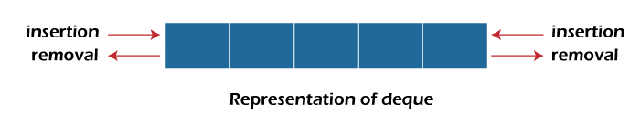
Input restricted Queue :
In input restricted queue, insertion operation can be performed ar only one end, while deletion can be performed from both ends
Input restricted Queue :
In input restricted queue, insertion operation can be performed ar only one end, while deletion can be performed from both ends
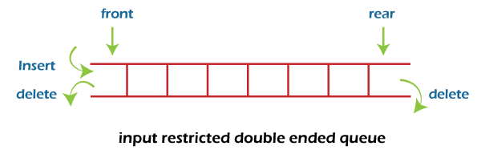
2. Output restricted Queue:
In output restricted queue, deletion operation can be performed at only one end, while insertion can be performed from both ends.
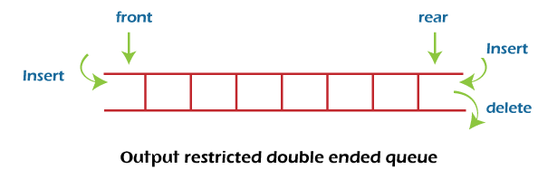
Operation on Dqueue
In a double ended queue, we can perform the following operations...
Insert at Front: Add an element to the front of the deque.
  - Insert at Rear: Add an element to the rear of the deque.
  - Delete from Front: Remove an element from the front of the deque.
  - Delete from Rear: Remove an element from the rear of the deque.
  - Peek Front: Retrieve the front element without removing it.
  - Peek Rear: Retrieve the rear element without removing it.
- Insertion at the front end:
In this operation, the element is inserted from the front end of the queue. Before implementing the operation, first we have to check whether the queue is full or not. If the queue is not full, then the element can be inserted from the front end by using the following conditions:
If the queue is empty, both rear and front are initialized with 0. Now, both will point to the first element.
otherwise, check the position of the front, if the front is less than 1, then reinitialize it by front=n-1 i.e., the last index of the array.
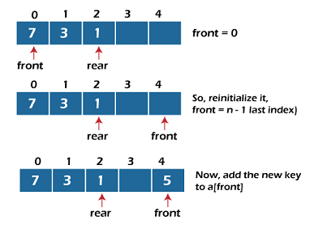
- Insertion at the rear end:
In this operation, the element is inserted from the rear end of the queue. Before implementing the operation, first we have to check whether the queue is full or not. If the queue is not full, then the element can be inserted from the rear end by using the below conditions:
If the queue is empty, both rear and front are initialized with 0. Now, both will point to the first element.
Otherwise, increment the rear by 1. If the rear is at last index ( or size -1), then instead of increasing it by 1, we have to make it equal to 0.
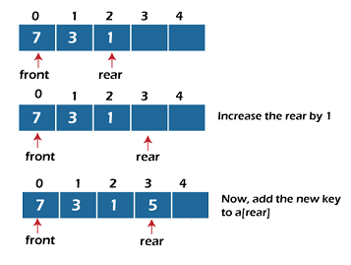
- Deletion at the front end:
In this operation, the element is deleted from the front end of the queue. Before implementing the operation, we first check whether the queue is empty or not.
If the queue is empty i.e., front = -1, it is the underflow condition, and we cannot perform the deletion. If the queue is not full, then the element an be inserted from the front end by using the below conditions:
If the deque has only one element, set rear = -1 and front = -1
else, if front is at end (that means front = size – 1) set front = 0’
else, increment the front by 1. (i.e., front = front + 1)

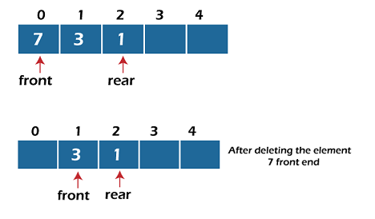
4. Deletion at the rear end:
In this operation, the element is deleted from the rear end of the queue. Before implementing the queue operation, we first check the queue is empty or not.
If the queue is empty, i.e., front = -1, it is the underflow condition, and we can’t perform the deletion.

If the deque has only one element, set rear = -1 and front = -1.
If rear = 0 (rear is at front), then set rear = n-1.
else, decrement the rear by 1 (or rear = rear – 1)

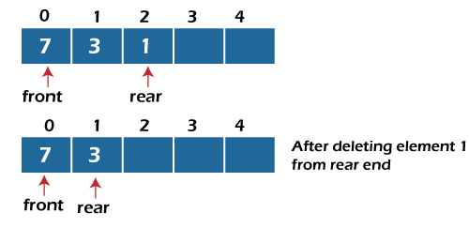

The basic operations of a deque:
- append(x) – Adds x to the right end of the deque.
- appendleft(x) – Adds x to the left end of the deque.
- pop() – Removes and returns the rightmost element.
- popleft() – Removes and returns the leftmost element.
- peek (front/rear) – View the front or rear element without removing it.
- clear() – Removes all elements from the deque.

Python Code for Min-Priority Queue (Dequeue Operation)

2. Input Restricted Queue (Inserting at the Beginning)

def delete_from_front(self):
"""Delete an item from the front of the queue."""
if self.queue:
return self.queue.popleft()
else:
print("Queue is empty! Cannot delete from the front.")
return None
def delete_from_rear(self):
"""Delete an item from the rear of the queue."""
if self.queue:
return self.queue.pop()
else:
print("Queue is empty! Cannot delete from the rear.")
return None
def display(self):
"""Display the current state of the queue."""
print("Queue:", list(self.queue))

3. Input Restricted Queue (Inserting at the Beginning)

Application of dequeue
- Queue Implementation: For tasks like scheduling and processing in FIFO order.
- Palindrome Checker: Efficient checking of palindromes by comparing characters from both ends.
- Sliding Window Algorithms: For problems like finding maximum/minimum in a sliding window.
- Circular Buffer: For implementing buffers that use a fixed amount of memory and wrap around.
- Undo/Redo Operations: Storing actions for undo/redo functionality.
- Breadth-First Search (BFS): Efficient traversal of graphs in level order.
- LRU Cache: Efficient caching using the least recently used eviction policy.

Summary
- Double ended Queue is a linear data structure, where the insertion and deletion operations are performed from both ends. It is also called as deque.
- In deque, there are two types...
i) Input restricted queue
ii) output restricted queue
- In input restricted queue the following operations are performed:
i) Inserting At Beginning
ii) Inserting At End
- In output restricted queue, the following operations are performed:
i) Deleting from Beginning
ii) Deleting from End

Application of Dequeue:
Deques provide a flexible and efficient data structure for applications that require frequent insertion and removal of elements from both ends. They are widely used in areas such as:
- Sliding window problems,
- Palindrome checking,
- Task scheduling,
- Multi-level cache systems, and
- Various graph algorithms (like BFS or DFS with backtracking).
The ability to access both ends of the deque in constant time makes it ideal for solving problems that require flexible, efficient data manipulation.

In Python, the deque (double-ended queue) is implemented using the collections.deque class. A deque allows efficient appending and popping from both ends (left and right).

Time Complexity of Operations on a deque:
append(x): Adds an element to the right end of the deque.
Time Complexity: O(1)) (amortized constant time).
appendleft(x): Adds an element to the left end of the deque.
Time Complexity: O(1).
pop(): Removes an element from the right end of the deque.
Time Complexity: O(1).
popleft(): Removes an element from the left end of the deque.
Time Complexity: O(1).
Extend (iterable): Adds all elements from an iterable to the right end of the deque.
Time Complexity: O(k), where k is the number of elements in the iterable.

